The Essentials

Growing Dahlias
  - Tabor Acres Farm
Dahlias are easy to grow and only require a few essentials items:  Good Soil, water, 6+ hours Sun, and protected from Cold!  Start with good soil that drains well and amend with 2” – 3” of compost and balanced natural fertilizer.  Once Shoots appear, Water enough to keep the soil lightly moist but not soggy!  Dahlia’s need at least 6 hours of direct Sun a day. At Tabor Acres we grow our dahlia in a field that receives sun all day.  Protect your dahlias from the cold. Plant tubers outside only after danger of frost has passed in Spring. |  | A Bundle of various Dahlias from 2023  Bumble Rumble – Collarette Dahlia Bloom 3 – 4”

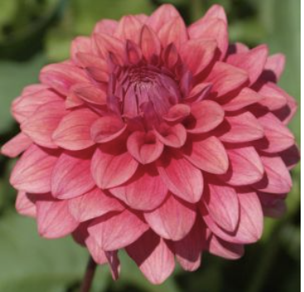 |  | Planting Method  I suggest planting your dahlia’s in groups of 3, 5, 7, 9, 12 etc. Depending on your variety they will become large bushes and will need support such as a tomato cage.

How far apart and how deep
Plant 12” apart. Place each tuber Horizontally 4”-6” deep. If you can see an eye, place the eye face up and cover with soil.
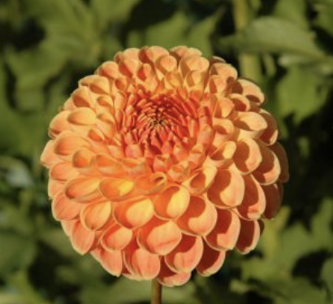 |  | Watering, when and how much  Start watering your dahlias once you see green shoots appear. Some dahlias sprout sooner than others, be patient, this can take up to a month. If you over water it can lead to tuber rot.

Pinching
Once your dahlias are 8”-12” tall, use sharp garden pruners to snip off 3”-4” of your dahlia. Snip above a set of leaves. This seems scary but it will help your dahlia produce more flowers and the stems of the flowers will be more manageable.

